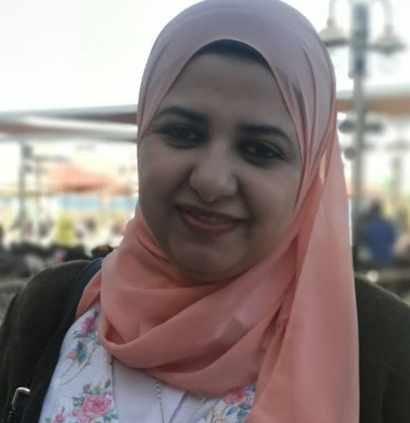
Sara Abdel-Reheem Mohamed Atta

Profile:

Gender: Female
Marital status: married.
Nationality: Egyptian
Birth: 5th February 1986, Saudi Arabia
Phone: 01005737159
E-mail: saraatta@aun.edu.eg
Saraatta2016@gmail.com

Education:
- Ph.D. in medical biochemistry, Faculty of Medicine, Assiut University, Egypt 2019.
- Masters in medical Biochemistry, Faculty of Medicine, Assiut University, Egypt,2015.
- Master's degree in clinical Pathology, Faculty of Medicine, Assiut University, Egypt, 2013.
- Bachelor of medicine and surgery (MBBCh), Assiut University, Egypt 2008.
- Graduation Grade: Excellent

Work Experience:
Lecturer of Medical Biochemistry, Faculty of Medicine, Assiut University (2019-present).
- A member of the Medical Biochemistry Department and teaching many of Assiut University faculties׳ such as Medicine, Pharmacy, Clinical Pharmacy, Dentistry, College of Nursing, and Veterinary medicine.
- Enhanced student comprehension by utilizing diverse teaching methodologies and techniques.
- Served as a mentor to new faculty members, offering guidance on classroom management and lesson planning techniques.
- Evaluated student progress through regular assessments, providing detailed feedback for improvement and growth.
- Used PowerPoint and Google Classroom technology to give presentations to student classrooms.

Quality Manager of Metabolic and Genetic Disorders lab, Assiut University, Egypt (2014- present).
- A ten-year background in implementing requirements of iso-15189:2012 and developing improvement processes through collaboration with cross-functional teams.
- Conducted workshops on tissue cultures, karyotyping, and Amino acid analyzer.
- Performed complex karyotyping analysis for prenatal diagnosis, guiding critical healthcare decisions for expecting parents.
- Conducted thorough audits to ensure adherence to medical standards and regulatory requirements, maintaining compliance consistently.
- Provided technical support during audits, demonstrating adherence to regulatory standards and best practices within cytogenetics.
- Increased laboratory safety, adhering to strict guidelines for handling biohazardous materials and waste disposal.

Administrative manager at Alfa Laboratories (2018-2021) and Al-Borg Laboratory clinical laboratories (2016-2018)
- Ensured enhanced communication among team members, fostering a collaborative and supportive work environment.
- First-rate computer, analysis, and research skills. Specialties include achieving set targets, generating new strategies, and maintaining accurate records.
Skills & Languages:
  - Work experience in genetic and clinical lab work as cytogenetic work., conventional PCR, Real-time PCR, TaqMan genotyping assay, Tissue culture, Amino acid analyzer, Spectrophotometry, HPLC, and Electrophoresis.
  - Good experience in quality control and internal audit of medical labs.
  - Good experience in the safety of medical labs.
  - Excellent experience in credit hours and modern teaching methodology.
  - Good experience using MS Office (Excel – Word – Power Point-Endnote -SPSS) - Passed ICDL Computer License.
  - Proficiency in spoken and written English.
  - Very good in Teamwork & Communication skills.

Workshops and Conferences:
Had Participated in conferences and professional development opportunities to stay up to date with the latest trends in the field.
  - The use of karyotyping and cytogenetic studies in diagnosing genetic disorders (2022-2023)
  - Credit Hour System training program (2011).
  - Quality Standards in Teaching Training program (2011).
  - New Trends in teaching training programs (2010).
  - Student Evaluation training program (2011).
  - Active learning training program (2011).
  - Workshop in tissue Culture and genetic engineering basis (2019)
  - Workshop on requirements for ISO 15189 for clinical laboratories (2015).
  - Workshop on internal audit in clinical laboratories (2015).
  - University teacher preparation course (2014).
  - Training Program on safety in clinical laboratories (2017).
  - Training program on uncertainty (2017).
  - Workshops on tissue culture and genetic engineering (2017).
  - Medical course on advanced statistics (ROC curve and Med. Calc) (2016).
  - Training program on End note and scientific literature (2014).
  - Research Methodology training program (2012).
  - Cardio-Pulmonary Resuscitation (C.P.R) (2009).

Publications:
Many national and international Publications in the field of Medical and Biochemistry research.
1. Increased Expression of Neprilysin Is Associated with Inflammation in Preeclampsia
2. Association of serum IL-30 and soluble GP130 with the risk of psoriasis vulgaris
3. Isolation and Crystal Structure of The First Pr(IV) Coordination Polymer and The Complex Anti-proliferative Activity Evaluation against Seven Cancer Cell Lines
4. Association Between Type 2 Diabetes Mellitus and TCF7L2 And FTO Gene Variants Among Upper Egyptian Population
5. Gephyrin and CYP2C9 Genetic Polymorphisms in Patients with Pharmacoresistant Epilepsy
6. Amino Acids Profile and Vitamin D Measurement in Hypertension in Egyptian Population
7. Role of Plasma Amino Acids Profiles in Pathogenesis and Prediction of Severity in Patients with Drug-Resistant Epilepsy

